THE EFFECTS OF CYCLONEIDAI ON WATER AND SANITATION FACILITIES IN CHIPINGE- CHIMANIMANI AREA, ZIMBABWE.

BY
SAMUEL S.P. MGANO

A RESEARCH PROJECT SUBMITTED IN PARTIAL FULFILLMENT OF THE REQUIREMENT FOR THE AWARD OF DIPLOMA IN WATER SANITATION AND HYGIENE TO THE AFRICA INSTITUTE FOR PROJECT MANAGEMENT STUDIES

SEPTERMBER 2019

DECLARATION
Declaration by the Student
This research project is my original work and has not been presented to any other examination body. No part of this research should be reproduced without my consent or that of the Africa Institute for Project Management Studies.

Name: _____________________Signature: _________________ Date____________
AIPMS/261/2019

Declaration of the Supervisor/Lecturer
This research project has been submitted for defense with my approval as the Africa Institute for Project Management Studies Supervisor.

Name: _____________________Signature: _________________ Date____________
Lecturer Supervising

For and on behalf of the Africa Institute for Project Management Studies.

Name: _____________________Signature: _________________ Date____________
Nairobi Branch Manager
DEDICATION
I dedicate this research project first and foremost to the Lord Jesus Christ who has helped me through every part of my life and family. To my wife and best friend who has been an unwavering rock in my life and my children who I live for.

ACKNOWLEDGEMENT
I humbly acknowledge God the Father for the strength he has granted me to finish my project and diploma. I appreciate my research supervisor and the faculty team for his positive criticism and dedicating his time and attention to enable me come up with this splendid piece of work.
I also thank Africa Institute for Project Management Studies for the support and service they have contributed towards my studies in the institution.

ABSTRACT
The purpose of this research project was to evaluate the effects of Cyclone Idai on Water and Sanitation Facilities in The Chipinge and Chimanimani Districts thus being able to better understand what has been repaired or not and the effects of these damaged facilities currently to the community at large in respect of W.A.S.H.

TABLE OF CONTENTS
DECLARATION………………………...……. ii
DEDICATION iii
ACKNOWLEDGEMENT iv
ABSTRACT v
TABLE OF CONTENTS vi
ABBREVIATIONS viii

CHAPTER ONE
INTRODUCTION OF THE STUDY
1.1 Introduction 1
1.2 Background of the Study 1
1.3 Statement of the Problem 3
1.4 Objectives of the Study 4
1.5 Research Questions 4
1.6 Significance of the Study 4
1.7 Justification of the Study 4
1.8 Limitation of Study 5
1.9 Scope of Study…………………………………………………………………...5

CHAPTER TWO
LITERATURE REVIEW
2.1 Introduction 6
2.2 Review of Theoretical Literature 6
2.3 Conceptual Framework 8

CHAPTER THREE
RESEARCH DESIGN AND METHODOLOGY
3. Methodology 8
3.1 Philosophical paradigm 8
3.2 Study Design 9
3.2.1 Study Site 9
3.3 Research Approach…….………………………………………………………11
3.4 Data needs, types and sources…… …………….……………………...………11
3.5 Presentation…………………………………………………………………….12
3.6 Validity and Reliability………………………………………………...………12
3.7 Ethics……………………………………………………………………… …12
CHAPTER FOUR
DATA, ANALYSIS, PRESENTATION AND INTERPRESENTATION OF FINDINGS
4 Presentation, analysis and Interpretation of findings …...13

CHAPTER FIVE
SUMMARY OF FINDINDGS, CONCLUSION AND RECOMMENDATIONS
5.1 Introduction …. ..17
5.2 Summary of the Study Findings …...17
5.3 Conclusion …...18
5.4 Recommendations …...19
5.5 Suggestion for Further Study …...19
REFERENCES 20

APPENDICES

LIST OF ABBREVIATIONS
RDC Rural District Council
DDF District Development Fund
PWSSC Provincial Water and Sanitation Subcommittee Council
DWSSC Provincial Water and Sanitation Subcommittee Council

CHAPTER ONE

INTRODUCTION OF THE STUDY

1.1 Introduction
The chapter comprises of the back ground of the study, statement of the problem with the research objective and the research questions. It paints a clear picture of where the study is coming from and where it’s going.
1.2 Background of the study
Water Facilities means any one or more devices used in the collection, treatment, or distribution of water for domestic and other legal uses, including systems of raw and clear water distribution storage reservoirs, deep and shallow wells, pumping, ventilating, and gaging stations, inlets, tunnels, flumes, conduits. (Lawinsider.com)
Sanitation refers to the provision of facilities and services for the safe management of human excreta from the toilet to containment and storage treatment onsite or conveyance, treatment and eventual safe end use or disposal. (According to World Health Organization (WHO)
According to Sphere Inadequate water quantity and quality is the underlying cause of most public health problems in crisis situations. There may not be sufficient water available to meet basic needs, so supplying a survival level of safe drinking water is essential. The priority is to provide an adequate quantity of water, even if it is of intermediate quality. This may be necessary until Minimum Standards for both water quantity and quality are met.
Cyclone Idai and subsequent flooding and landslides affected Malawi, Mozambique, and Zimbabwe over the period of March 4–17th, 2019, with severe repercussions for an already fragile part of Southern Africa and raising the prospects of significant cross-border impact. The Cyclone has affected around two million people across the three countries and left a trail of destruction with many people dead, missing or displaced, as well as crops and livestock lost and critical infrastructure destroyed. With the Ministry of Health in Mozambique declaring a cholera outbreak on March 27th, 2019 and over 4,000 cases of cholera recorded along the corridor as of May 1st, 2019, a coordinated regional effort to control the spread of diseases is critical
(World Bank Document).

The impact of Cyclone Idai was really felt in my home area, Chipinge and Chimanimani as it made land fall on the 15th of March 2019. It started with huge wind speeds and high volumes of rain, the local communities and people at large were caught unawares and there were no effective early warning systems. Many people were in their homes when the Cyclone came. In a little community call Koppa the water started to rise and people panicked then ran to the nearest police station for safety but that was a big mistake as Koppa police station was situated near the convergence of two rivers. Consequently, the rivers (Nyahode and Rusitu) burst their banks and countless people were killed and washed away. In Chimanimani the situation was the same as infrastructure was destroyed and lives lost.
This Cyclone impacted three provinces that is Manicaland, Masvingo, Mashonaland East but the worst of the storm was in Chimanimani and Chipinge Districts in Manicaland. The rains averaged 400mm and caused flash floods across the three provinces. Dams and weirs burst and bridges where washed away. The very fragile road networks were destroyed making rescue missions nearly impossible if not by air helicopters. Hospitals and clinics were washed away or damaged leaving the Central Hospital in Chipinge to initially cover both Chipinge and Chimanimani patients.
On the evening of March 16th, President Emmerson Mnangagwa, declared a state of disaster. This facilitated the flow of information and aid in and out of the areas that were affected.

1.3 Statement of the Problem
The effects of Cyclone Idai on Water and Sanitation facilities is The Chipinge and Chimanimani Districts.
After it was declared a national crisis, there was the flow of information and aid into the affected areas, that is when the partial extent of the damage was realized by the rest of the country and world. The problem is there was (initially) no real time assessment of how many water and sanitation facilities that were affected by Cyclone Idai. According to the Provincial Water and Sanitation Subcommittee (PWSSC) Rapid Assessment Report dated 7 April 2019, they did not know the difference between a borehole affected or not affected by Cyclone Idai. But with time, information started trickling in yet even now, months down the line there are still gaps in the information when you compare the different sources of information. And thus the thrust of my research is to find out how many water and sanitation facilities were repaired or rehabilitated and what was the effects to the communities has been.
According to (ACAPS Zimbabwe Tropical Idai Briefing Note on 19 March 2019) the Cyclone has a severe impact on WASH infrastructure, compromising access to safe drinking water for at least 42,000 people in affected areas. Across the affected areas, over 250 boreholes, 50 springs and 16 water supply systems have been damaged. 50 schools have no functional WASH facilities in Chimanimani and Chipinge districts (OCHA 27/03/2019)
This was the information supplied initially but 6 months on there is need to evaluate the figures again and see the effects of lack of these facilities where they have not been repaired.
The lack of water and sanitation facilities might affect the health of the communities as some of them have been displaced and live in survivors’ camps where they are crowded. This might introduce vectors and other pathogens that will affect the health of the community. So, having clean water for washing hands and bathing will help curb the effects of diseases in the community. Adequate sanitary facilities will take care of the solid wastes but all these need to be have a real backing of behavioral change to know what to do and what not to do to maintain a clean environment.

1.4 Objectives of the Study

1.4.1 General Objective
The main objective of the study is to find out the effects Cyclone Idai has had on water and sanitation facilities in the Chipinge and Chimanimani area.

1.4.2 Specific Objectives
- To evaluate the number of facilities negatively affected by the Cyclone.
- To find out the estimated cost of the damages
- To find out how many WASH facilities have been repaired to date.
- To determine the effect of lack of water and sanitation facilities on the different communities.

1.5 Research Questions
- To what extent Cyclone Idai has damaged or destroyed water facilities in the Chipinge and Chimanimani Districts?
- To what extent Cyclone Idai has damaged or destroyed sanitation facilities in The Chipinge and Chimanimani Districts?
- What is the extent of repair or rehabilitation of the water facilities in Chimanimani and Chipinge Districts?
- What is the extent of repair or rehabilitation of the sanitation facilities in Chimanimani and Chipinge Districts?

1.6 Research Hypothesis

There is no significant damage or destruction to water and sanitation facilities because of the Cyclone Idai.

1.7 Justification of Study
It is important to do this study as we need to see if there was any effect on the living, surviving communities by the Cyclone in terms of water and sanitation. The Cyclone destroyed many homes and infrastructure and was the author of countless lives lost. As this was tragic the way forward is to find out what we can do to help the survivors live a healthy lifestyle. The study is to find out the extent the Cyclone had on the water and sanitation facilities of the set areas, this will help us trace the areas that need the most help in terms of rehabilitation and health services. The study also highlights that extent of aid in this area as we are now more than 5 months after the Cyclone and if there is need for any further work in terms of rehabilitation.

1.8 Limitation of the Study

1.8.1
Some of the information required by the researcher was hard to come by as some organizations refused to release information and had to take some initiatives to be able to get information

1.9 Scope of the study
The study was carried out in The Chipinge and Chimanimani Districts. The main aim was to find out the effects of Cyclone Idai on water and sanitation facilities in the set area thus also highlighting if there has been any after effects and rehabilitations. This is from 16th of March 2019 to the 26th September 2019.

CHAPTER TWO
LITERATURE REVIEW
2.1 Introduction
The review is an important part of the objective approach to research in all fields of enquiry. This is aimed at identifying the research gaps to the existing literature and emphasizing on the need to carry out this study which is concerned with examining the importance of water sanitation and hygiene in development sector. The purpose of this literature review is to provide the researcher with means of getting to the frontiers of knowledge of the issue under investigation. To this end, the present chapter covers a review of theoretical literature review of analytical literature of analysis and gaps to be filled, a summary of the chapter and the conceptual framework.

2.2 Review of Theoretical Literature
2.2.1 Water and Sanitation Infrastructure
PWSSC (2019), found that there is more water (55) and sanitation facilities were damaged in Chimanimani District more than other districts, the team noted that some sites included on the lists were part of the districts rolling plans and where not necessarily damaged by the cyclone. Some of the water points included on the list were reported as non-functional prior to the Cyclone. The workmanship on latrine construction and substandard material for example some were built with unburnt bricks, without cement and were also not roofed.
Rapid Impact and Needs Assessment (2019), For the Water Supply and Sanitation (WSS) sector, we used data from OSM to highlight facilities and feature in the WSS sector, including dams, reservoirs, wastewater facilities, water pumps, wells, boreholes, water towers, and water tanks. We also used FAO and Care International data to identify additional dams and incorporated those into the OSM data we collected. We overlaid the rainfall intensity later with the WSS features to determine impact from the cyclone. We also identified the type of dam using satellite imagery, separating the dams into large concrete dams and small natural dams. We used this to identify dams and reservoirs that were impacted by flooding.

World Bank Documentation (2019), The Cyclone caused substantial flooding, resulting in numerous deaths and significant damage to infrastructure, property, crops, and livestock. This included damage to water distribution and infrastructure systems. There is also an elevated risk of water-borne diseases, including cholera as Zimbabwe has been experiencing a cholera outbreak since September with a current total caseload of suspected 10,730, of which 317 were confirmed cases.
WASH cluster Cyclone Idai report as 13 May 2019, according to the Ministry of Health and Child Care Environmental Report the district sanitation coverage stood at 19% and water coverage stood at 91% before the cyclone. With the effects of cyclone, the situation worsened as most of the springs which supplied the water to communities in north eastern parts of the district were washed away and some were contaminated while latrine collapsed due to heavy rains. The district carried WASH technical assessments to inform the WASH response and enable planning.
Acaps, Zimbabwe Cyclone Idai update (2019), In Chipinge town, 33,000 residents have no safe drinking water as most of the water pipes and a water treatment plan have been destroyed by floodwaters. The sewage network in Chipinge Gaza town is also non-functional which poses health risks as raw sewage is likely to both seep into floodwater, then contaminating groundwater and boreholes. In Chimanimani town, it is estimated that 5,000 meters of water pipes were destroyed, hindering 9,000 people from accessing clean water. (MSF 27/03/2019; OCHA 27/03/2019). Inadequate WASH infrastructure severely elevates the risk of disease outbreaks such as cholera (MSF 27/03/2019; OCHA 27/03/2019; UNHCR 25/03/2019).
It is highlighted as the above literature in tells that there is a gap in the information in terms of what is on the ground and further research is needed to find out what is the exact number of water and sanitation facilities that are affected. There is an assumption that the lack of these facilities will cause waterborne diseases but is that what has happened as we need to review the current information if that has happened.
3. Methodology
The methodology used by the PWSSC is quantitative in nature thus showing in tabular form the gaps as they did not have much information, l will be using the same methodology thus adjusting and finding out the correct real time data of the study.
This section prospects a schematic interpretation of the conceptual framework as shown in the figure below.

Figure 1.1 Conceptual Framework
Independent variables Dependent Variables
Water facilities Chimanimani

Sanitation facilities Chimanimani
Cyclone Idai 15th March 2019
Water facilities Chipinge
Sanitation facilities Chipinge

3.1 Philosophical paradaigm:
Epidtemology is a stem of philosophy that studies knowledge or knowing (Alex Lyon) With that meaning in mind the researcher then asks how do the literature authors know that they claim to know. The researcher then assume that knowledge is already out there and we need to grasp it in a way that will better represent and interpret those findings. I’m choosing a quantitative approach to my research were Cyclone Idai is my independent variable and Chimanimani and Chipinge area my dependent variables. We are trying to see if the effects of Cyclone Idai on the water and sanitation facilities in these two locations are devastating or not.
3.2 Study Design
The researcher will be doing a case control design. It will have a timeline and this will be from March to the September 2019. As the researcher knows the outcome of the number of water and sanitation facilities affected by Cyclone Idai and the amount that we repaired or not in the two locations that is Chimanimani and Chipinge. At the back-ward side of the time line we mark the occurrence of Cyclone Idai as it makes landfall on the 15th of March 2019.We are looking the relationship between the Cyclone and the amount of damage that was done per location over the space of time. The parameters are observational as there is no random data that we are using, it will also be in the back-ward directionality because the outcome is known and it’s going to be retrospective because the study starts once the outcome is known already.
3.2.1 Study Site
The study site is based in Chimanimani, Chipinge areas in the eastern part of the Zimbabwe. Why this site was chosen is because it was recently affected by Cyclone Idai that devastated the already fragile community by killing countless lives and destroying a lot of infrastructure in its wake. As the population relies heavily on water and sanitation facilities for their healthy life style the research is on the impact of Cyclone Idai on the noted facilities.
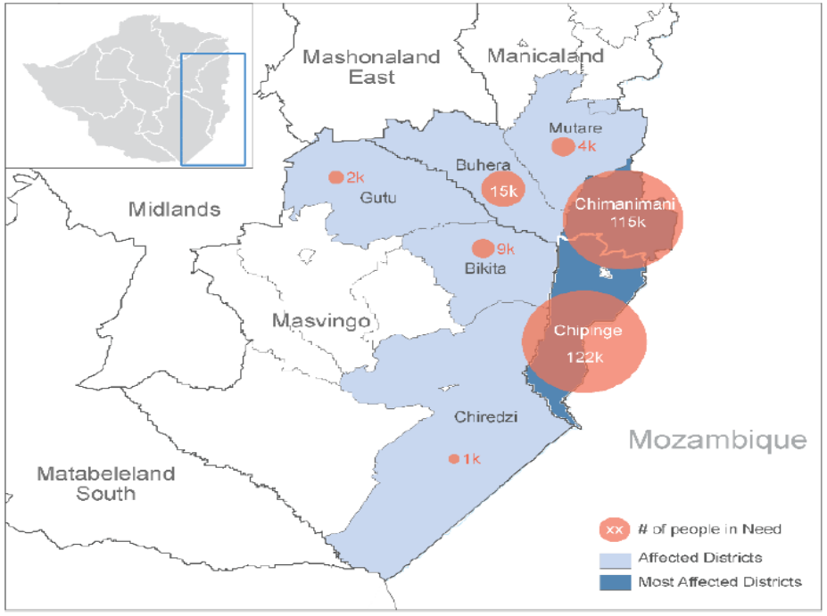
Picture adapted from (acaps, 2019)

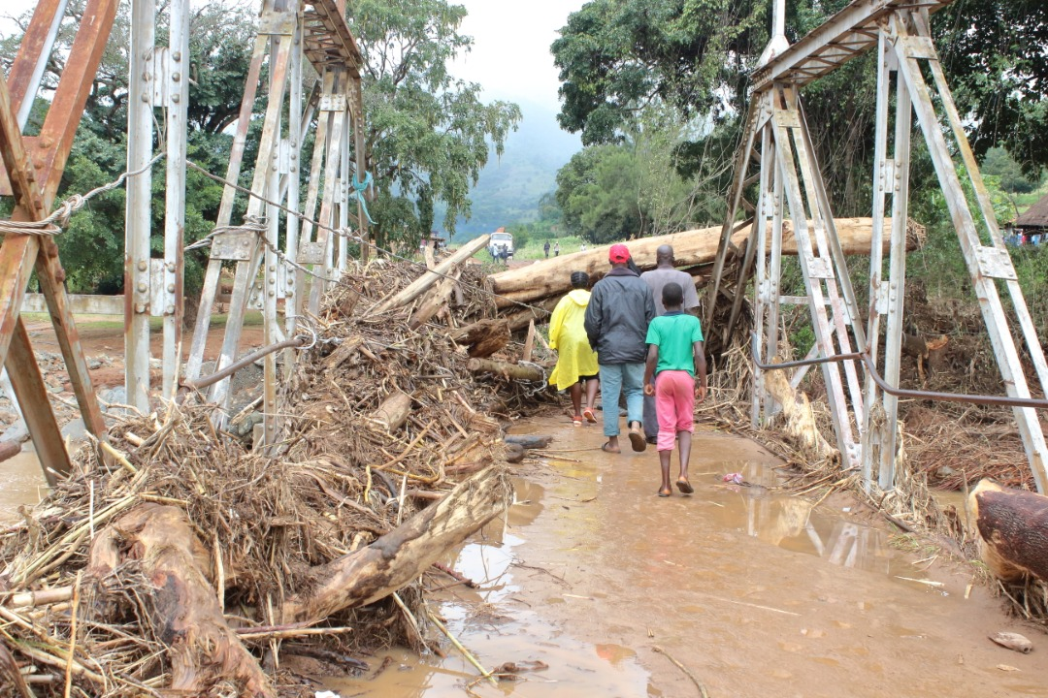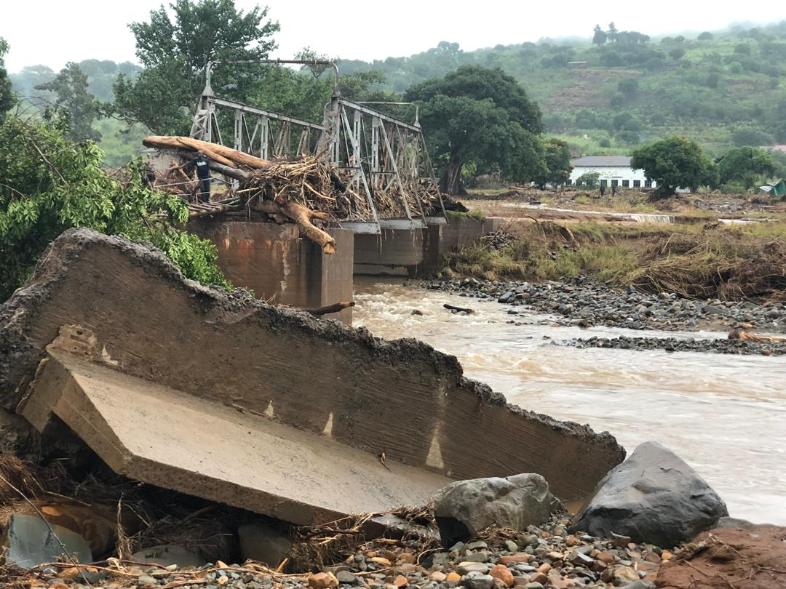
Picture taken by my team when we volunteered as first to aid Cyclone victims in Rusitu area, a week after the Cyclone made landfall.
This highlights total and absolute destruction of infrastructure.
3.3. Research Approach
The research will be focused on using quantitative data analysis that will show and prove the exact number of facilities that were affected by Cyclone Idai and the relationship effects of the location and the amount of damage suffered.
3.3.1. Research Method
The method of research will be to pose a question or hypothesis than collect data. The researcher will be using primarily secondary data that was or/is collected by the different governmental and NGO organisations that are currently based in Chipinge and Chimanimani District. After collecting the data then it will be presentated and analysed.
3.4 Data needs, types and sources
The data that is used in this research is secondary data that was collect both the RDC of Chipinge and Chimanimani, and DDF of Chipinge. There is information that l was given by the PWSSC that is up to date and l have been given authority to use in this study. This data was given to me in Tabular form through surveys they have been caring out, also some of the data has been extracted from updated WASH cluster meeting and documents formulated and presented by the NGO’s currently doing work in The Chipinge and Chimanimani Districts.
3.4.1 Population, Sampling procedure and Data collection:
The target population was that which was located in The Chipinge and Chimanimani Districts. According to PWSSC one of the sources of data that lm using; purposeful sampling and snowballing: This was then done in consultations with the local structures for wards and villages that were visited. This was informed by the statistics received on extent of the problem. Case studies were also used to understand the problem better, from individual narratives and experience.

3.4.2. Data Analysis
Data used was secondary data from update reports of the Idai sub committees and RDC findings and DDF findings from the different locations. Data was then put in an excel spreadsheet and interpolated to show the results in numerical form.
3.5. Presentation
Data will be presented in tabular for as it best shows the figures that we are working with and presents a clear picture of the results.
3.6. Validity and Reliability
The research data was obtained by the different departmental sections of the civil protection unit. There were teams that went out and carried out the survey and reported back to the data capturing team that then interprets the data. With the support of the NGO’s that need data for funding and other purposes there was need to do sampling and a survey was carried out. These are done periodically as there might be changes in parameters and conditions. Auditors have been deployed to make sure what has been reported is true so that the data can be valid and reliable.
3.7 Ethics
All information that l have used in my research has been authorized by Rural District Council ( Ms Nyanhete WASH Cluster coordinator, CSO) :anyanhete@gmail.com, Mr Sundawo DDF – DWSSC Chairman , District Coordinator: issacsundawo@gmail.com

4. Presentations of findings, Analysis and interpretation (chapter four)

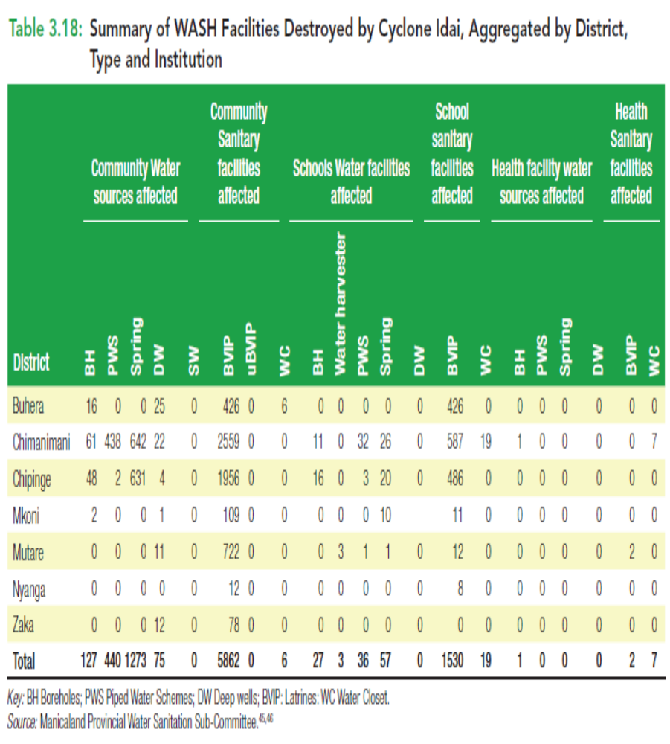
Table derived from (Report Z. R., 2019)
The above table answers the question as it shows the full extent of the impact of Cyclone Idai on water facilities in the Chipinge and Chimanimani Districts.

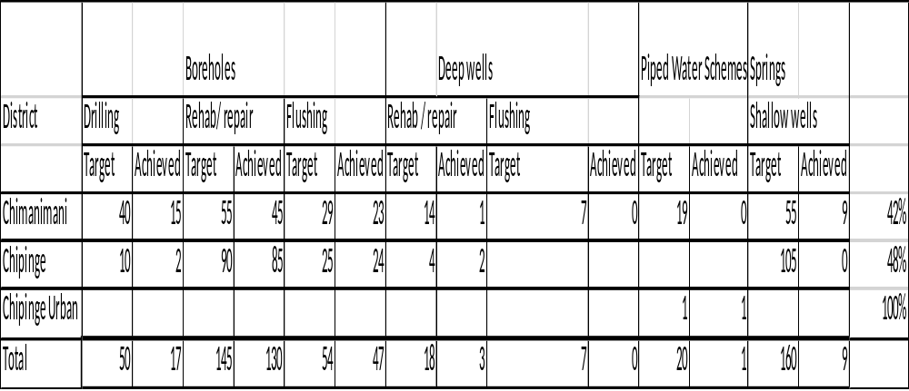
Formulated and adapted from both (Council, 2019) and (COORDINATION, 2019) data provided.
On the Table the sub title “Target” refers to what they are hoping to repair or rehabilitate. As it can be noticed that in Chimanimani there 219 sites that were affected negatively by the Cyclone and targeted for work to be done so that communities can access clean safe water. In Chipinge that are 234 sites that were negatively affected and targeted for work to be done so that communities can access clean safe water. It has to be noted that as much as Chipinge Urban has had 1 site (which is to the water treatment plant that was affected and repaired by Plan International) but there is still a water shortage in Chipinge urban that has gone for 2 months.
The table also shows currently how many have been repaired and rehabilitated. The troubling thing is that according to the above percentage only 42% of the affected sites have work been done in Chimanimani and 48% of affected sites have work been done in Chipinge to rehabilitate or drill new holes.

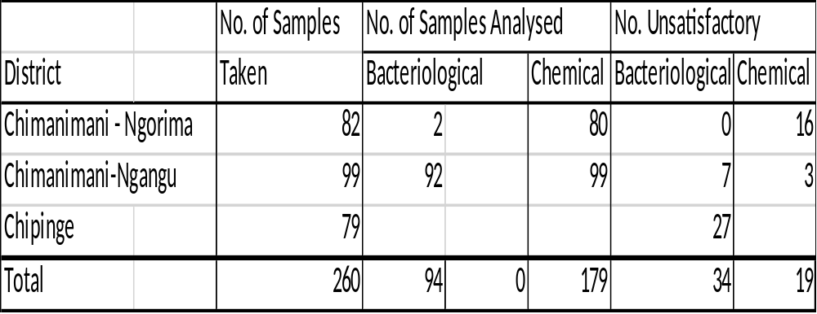
Table above is information extracted from (COORDINATION, 2019)
The above table shows that as much there are some work done in terms of water facilities being activated in Chimanimani, Chipinge the water quality tests have shown that not all water sources can be used for drinking water. At least 34 Bacteriological samples were unsatisfactory and 19 Chemical samples. We can then conclude that not all water sources are satisfactory and a hygiene promotion program needs to be effect. Ministry of Health have just finished and oral Cholera vaccination campaign and no typhoid, cholera cases have been reported in the districts.
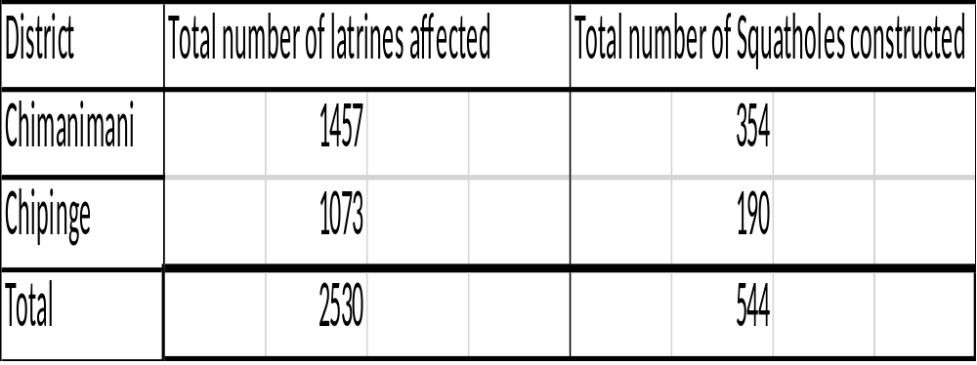
Table from (Council, 2019)
The above table show the number of latrines affected by Cyclone Idai in Chimanimani, Chipinge area. We then see that Chimanimani has a slightly a greater number of Latrines that were affected than Chipinge. This data combines both household latrines and school latrines. The table also shows that number of squat holes that have been constructed to date.
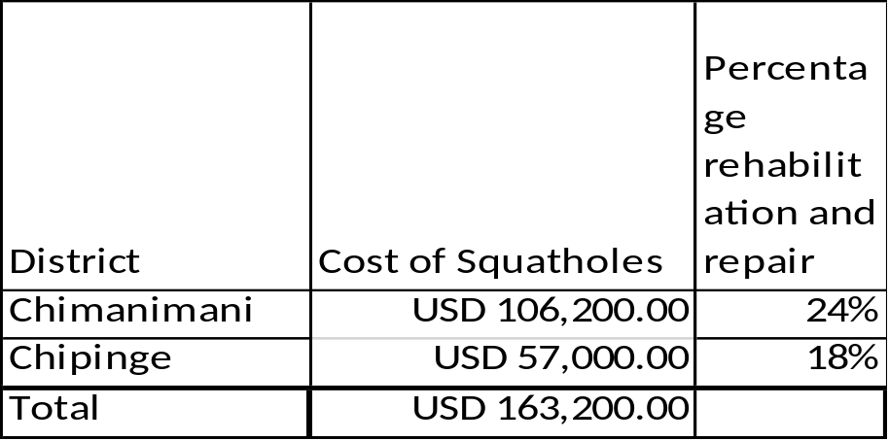
Table from (COORDINATION, 2019) and (Council, 2019)
The above table highlights that percentage of repairs and rehabilitations that have been done till date in the different districts and the cost of these projects. The cost per squat holes is USD$300. As indicated 24% of what is needed has been done in Chimanimani and 18% in Chipinge. This means that there is much to be done in terms of sanitation facilities. This means there might be an outbreak of diseases but some effects are long acting and will need to be researched further over time like malnourishment.

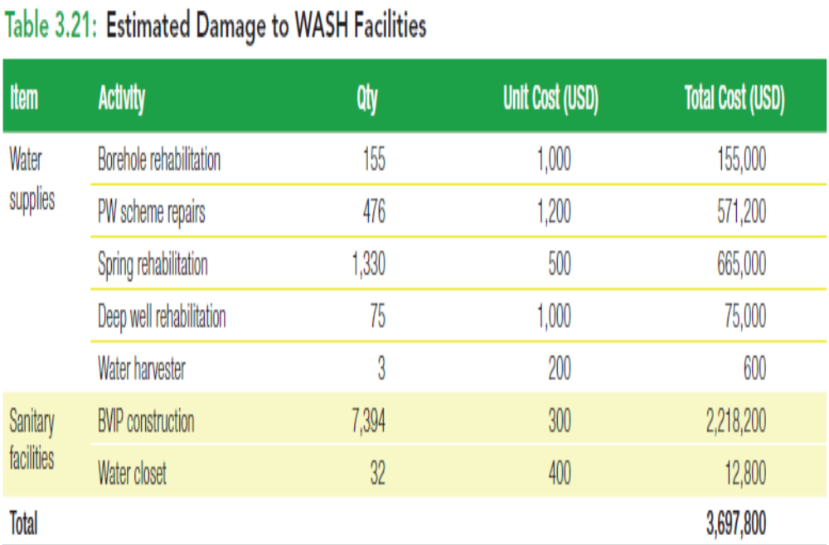
Table from (Report Z. R., 2019)
The above table shows the cost of damage on WASH facilities.

.

CHAPTER FIVE
SUMMARY OF FINDINGS, CONCLUSIONS AND RECOMMENDATION
5.1 Introduction
This chapter show the findings of the study, conclusion and recommendations
5.2 Summary of Findings
5.2.1 To what extent Cyclone Idai has damaged or destroyed water facilities in the Chipinge and Chimanimani Districts?
There was a lot of destruction from Cyclone Idai in Chimanimani, Chipinge area in water facilities. Seeing a total of 1232 facilities damaged in Chimanimani and Chipinge having 724 facilities damaged or washed away.

5.2.2 To what extent Cyclone Idai has damaged or destroyed sanitation facilities in The Chipinge and Chimanimani Districts?
There was a lot of destruction from Cyclone Idai in Chimanimani, Chipinge area in sanitation facilities. Seeing a total of 3172 facilities damaged in Chimanimani and 2442 facilities affected by Cyclone Idai in Chipinge.
5.2.3 What is the extent of repair or rehabilitation of the water facilities in Chimanimani and Chipinge areas?
Of the targeted water facilities only in Chimanimani 42% work has been done make them usable again providing supposed clean safe water. And in Chipinge of the targeted water facilities only 48% of the sites have been worked on to provide clean water. It has to be highlighted that the target is not the total number facilities that have been damaged.
5.2.4 What is the extent of repair or rehabilitation of the sanitation facilities in Chimanimani and Chipinge areas?
The extent of rehabilitation of sanitation facilities in Chimanimani ranges at 24% from the targeted numbers and 18% in Chipinge from the targeted 1073 latrines that were affected. As much as we can assume that by now there should an outbreak of diseases according to the Ministry of Health, currently there is no outbreak but some effects will be seen long term like stunted growth and malnutrition. So further study needs to be done so that we can see the after effects of the Cyclone long term.

5.3 Conclusions
Based on the findings the researcher confirmed that there is a gap in information and need for further study as more and more parameters change. The previous literature was out dated and needs to be modified with better and up-to-date information. This data will then shows us the full extent of the Cyclone to date with regards to WASH facilities- damage and destruction thereof.

5.4 Recommendations
5.4.1 Water Sources
It will be prudent that more water sources would made available. As the above data on water testing shows some of the sources are not drinkable and there is an apparent need to water test every water source before it is used. Because of the Cyclone, waste might have wash into underground water sources thus making them fail the water tests. I recommend more water testing to be done so that the water that been used may be checked if it’s safe or not.
5.4.2 Sanitation Facilities
The study shows that there is more work to be done in terms of providing sanitary infrastructure. This will curb the outbreak of disease and increase quality of living and dignity. More Dignity and Hygiene kits must be given out to the communities, the construction of sanitation facilities for disabled people and girl friendly latrines at institutions must be a priority. Community latrines must also be constructed.
5.4.3 Health
At one time there was open defecation at the General Hospital because they did not have capacity in terms of water and sanitary services because of the huge amount of needs. The study recommends that more work needs to be done to WASH services so that we can curb diseases.
5.5 Suggestions for Further Study
There is apparent need for further study as conditions change and new information is coming in daily. With the huge amount of facilities not serviced there is need to monitor and evaluate the effectiveness of the projects and the result of the these such projects on the community at large.
The other area which will warrant further and in-depth study is that of the long- term effects of Cyclone Idai on the health, nutrition/ malnutrition and possible stunted growth of the (current) children who have been affected by it.

References
acaps. (2019). Zimbabwe Tropical Cyclone Update 1.
Bank, W. (2019). Zimbabwe Idai Recovery Project.
Coty-Barker, V. (n.d.). How to Formulate a Hypothesis.
Council, R. D. (2019). Idai WASH sub committee.
David Russell, L. C. (n.d.). Quantitative Data Analysis.
Hank Green, S. S. (n.d.). What is Phyilosophy?
Lyon, A. (n.d.).
P. C. (2019). WASH updated report. Chipinge, Chimanimani.
PWSSC. (n.d.). Rapid Assessment 7 april 2019.
Report, W. B. (n.d.). Cyclone Idai Reort 2019. Chipinge, Chimanimani.
Report, Z. R. (2019). RINA.

